**.match( ) and .matchAll ( )**

**Study these deelply along with the regular expressions**

**These are super handy and powerful**

.indexOf( ) // searches from beginning to last of string // gives the very first occurrence of word

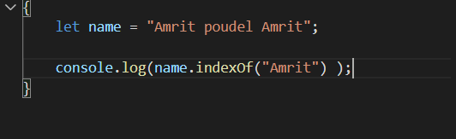

returns index of first occurrence of “Amrit”

.lastIndexOf ( ) // searches from last to beginning of string // gives us the last occurrence of the word

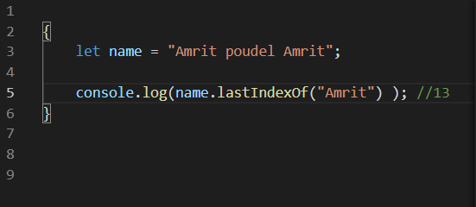

returns index of last occurrence of “Amrit”

**Both returns -1 if the word is not found in the string**

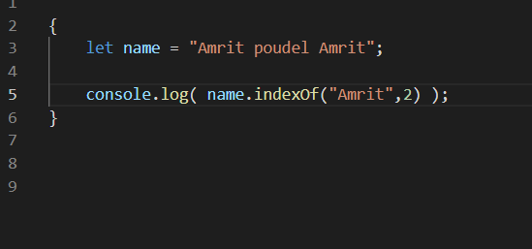

we want to search “Amrit” starting from the index 2 to the last

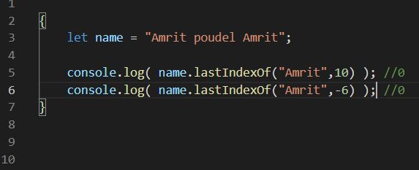

here it searches “Amrit” from the index 10 or -6 to the beginning

.search ( ) // searches for a word in the string and returns the index

Unlike .indexOf( ) it doesnot take the second argument as the starting position

.includes ( ) // returns true of false if the given string contains the given word

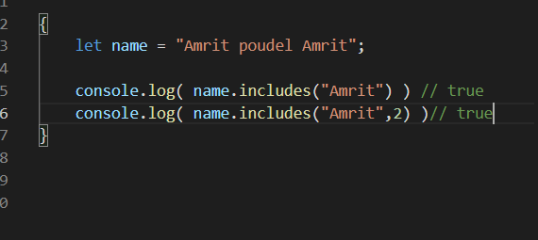

.startsWith( searchvalue, startIndex ) // returns true of false if the given string starts with the given word

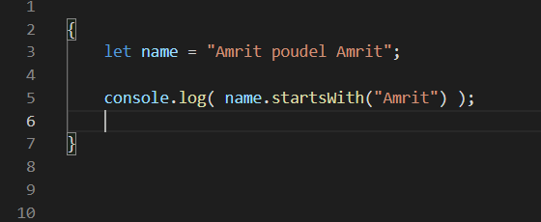

What is means is 0 position bata “Amrit” bata start vaa xaa ki xainaa ?

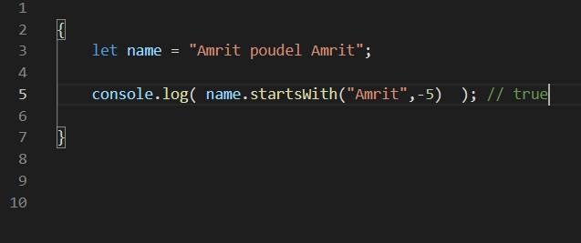

here -5 position maa “Amrit” bata start vaa xaa ki nai ??

.endsWith( searchvalue, length )

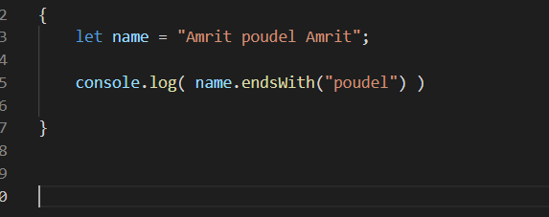

It says if the name wnds with “poudel” or not for the full length of name ??

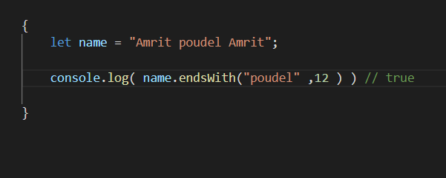

It says if the string name ends with “poudel” for the length 12 of the given string